Bevill State Community College
APA Style In-Text Citation

APA Style
IN-TEXT CITATION
APA style is a set of guidelines established by the American Psychological Association for presenting written research. See: The American Psychological Association. (2010). Publication manual of the American Psychological Association (6th ed.). Washington, DC: American Psychological Association.
Copies of this manual are available at the LCC Library and are located on the 2nd (Ref BF 76.7 .P83 2010) and 3rd floor (BF 76.7 .P83 2010). Information is also available at:
• www.apastyle.org • www.bscc.edu/library/help/citation

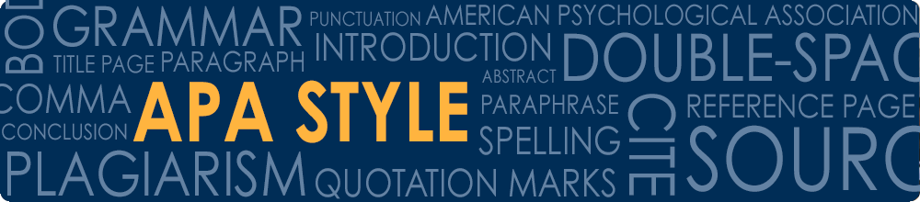

BASIC FORMAT AUTHOR-DATE STYLE
In addition to having a references list at the end of your paper, you must give credit to sources that you use within your paper. Usually the author’s last name and publication date are enough for the reader to identify the complete reference in the references list. See the examples below for variations of this general rule.

Author’s name in text
APA Manual 6.11 (p. 174)
If you cite the author’s name in your paper, cite only the publication year in parentheses at the end of the sentence:
In Silent Spring, Carsen (1962) made an intelligent and passionate case for the immediate cessation of careless and pervasive pesticide use.

References
Carsen, R. (1962). Silent spring. Greenwich, CT:
Fawcett.

Author’s name in reference
APA Manual 6.11 (p. 174)
If you do not cite the author’s name in your paper, then include both the author’s last name and the publication year in parentheses at the end of the sentence separated by a comma:
Silent Spring was one of the first books to discuss dangers of pesticide use (Carsen, 1962).

Citing two authors
APA Manual 6.12 (p. 175)
Cite both authors’ last names and the publication date every time you refer to the work in your paper. In parentheses, use an ampersand (&) to separate the authors’ names:
They believe that a key aspect of the growth of dance on the American cultural scene has been the expansion of dance education in varied forms (Kraus & Hilsendager, 1981).

Citing three, four, or five authors
APA Manual 6.12 (p. 175)
Cite all the authors’ last names and the publication date the first time you refer to the work. If you refer the work again, cite the first author’s last name followed by et al.
Oliver, Chiras, and Reganold (2004) offer sustainable solutions to global resource and environmental problems.
Oliver et al. argue that...

Citing six or more authors
APA Manual 6.12 (p. 175)
Cite the last name of the first author followed by et al. and the publication date the first time you refer to a work and in each new paragraph. If you cite the work again in the same paragraph, do not include the year of publication.
Knight et al. (2002) found that college students have been exposed to alcohol before attending college.
In the research study, Knight et al. focused on interviewing undergraduate students.
No author listed (cite by title)
APA Manual 6.15 (p. 176)
When there is no author listed for a work, include the first few words of the title followed by the publication year in parentheses at the end of the sentence:
Many in the liquor industry argue that the ban on television liquor advertising gives those in the beer and wine industry an unfair advantage (“Liquor Advertising,” 2002).
Citing part of a work (page and paragraph numbers)
APA Manual 6.19 and 6.05 (p. 179 and 171-172)
Page Numbers
When you quote or paraphrase a specific part of a print or online source give the relevant page, chapter, figure, table or equation in parentheses at the end of the sentence after the author’s last name and publication date.
“Time management is an important survival skill” (Brown, 2003, p. 6).

Paragraph Numbers
In an online source that does not provide page numbers, give the paragraph number, if provided, preceded by the abbreviation para. after the author’s last name and publication date.
The water level in the Great Lakes has gone down in recent years (Assel, 2004, para. 5).

Personal communications (interview, letter, email)
APA Manual 6.20 (p. 179)
References to personal communications do not appear in the reference list. Personal communication references in text should provide the initials and last name of the person and the exact date of the communication.
J. J. McKenzie (personal communication, August 30, 2002) confirmed that he was one of the unofficial organizers of the teachers’ strike.
He confirmed that he was one of the unofficial organizers of the teachers’ strike (J. J. McKenzie, personal communication, August 30, 2002).

Secondary Sources
APA Manual 6.17 (p. 178)
Whenever possible, use original source material, not secondary. If you must use an indirect source, include the primary source in the paper and the secondary source in the reference list. For example, if you read about Fruzetti’s work in an article by Martens, include Fruzetti in the in-text citation and Martens in your reference list:
Fruzetti explained that no effective treatments for borderline patients had been established until the past decade (as cited in Martens, 2005).

References
Martens, W.H. (2005). Therapy on the borderline: Effectiveness of dialectical behavior therapy for patients with borderline personality disorder. Annals of the American Psychotherapy Association, 8(4) 5-13.

